

# 

# *UNIVERSITY OFGREENWICH*

# [COMP-1649-M02-2023-24 Human Computer Interaction and Design](https://moodlecurrent.gre.ac.uk/course/view.php?id=95789" \o "COMP-1649-M02-2023-24 Human Computer Interaction and Design (FPT Can Tho))

|  |  |
| --- | --- |
| Student name | Nguyen Van Lap |
| ID number (00xxxxxxx) | 001353336 |
| Lecturer/Tutor name | Tran Thi Kim Khanh |
| Student submission date | November 24nd, 2023 |

**Table of Contents**

UNIVERSITY OF GREENWICH 1

COMP-1649-M02-2023-24 Human Computer Interaction and Design 1

1 Introduction 5

2 Background literature 5

2.1 HCI Research 5

2.2 HCI Theory 5

2.2.1 Cognitive Psychology 6

2.2.2 Interaction Design Theory 7

2.2.3 Modes of Interaction 7

2.2.4 Types of Interaction 8

2.2.5 Design Principles 8

2.2.6 Design Pattern 9

3 Design Process 10

3.1 Conceptual Design 10

3.1.1 User Requirements 10

3.1.2 Problems and Solutions 10

3.1.3 Hierarchical Model 10

3.1.4 Conceptual Model 10

3.2 Design principles 13

4 Prototype 16

4.1 Physical Prototype 16

4.2 Low-fidelity Prototype 18

4.3 Mid-fidelity Prototype 20

5 Research Study 27

6 Conclusion 38

References 40

Appendices 41

**Table of Figures**

Figure 1 The MySSI application (SSI, 2022) 5

Figure 2 Hierarchical Model of the Diving App 10

Figure 3 Conceptual Model 11

Figure 4 Visibility principle of my interaction design 13

Figure 5 The feedback principle of my interaction design 14

Figure 6 The Constraints principle of my interaction design 14

Figure 7 The consistency principle of my interaction design 15

Figure 8 The affordance principle of my interaction design 16

Figure 9 Waterproof case (Armor, 2022) 17

Figure 10 The front and back of my waterproof case 17

Figure 11 The Diving application’s the login page in low-fidelity 18

Figure 12 The Diving application’s the sign up page in low-fidelity 18

Figure 13 The Diving application’s the home page in low-fidelity 19

Figure 14 The Diving application’s the tracking page 19

Figure 15 The application icon 20

Figure 16 The Diving application’s the login page in Mid-fidelity 20

Figure 17 The sign up interface of diving application in mid-fidelity 21

Figure 18 Log in successfully in mid-fidelity 21

Figure 19 The Diving application’s home page in mid-fidelity 22

Figure 20 The Diving application’s Add New Diving page in mid-fidelity 22

Figure 21 The Diving application’s Tracking page in mid-fidelity 23

Figure 22 The photography interface of the Diving applicarion in mid-fidelity 24

Figure 23 The video recording interface of this application in mid-fidelity 25

Figure 24 The connections setting page of this application in mid-fidelity 25

Figure 25 The account management page of the Diving application in mid-fidelity 26

Figure 26 The terms and policies page of the Diving app in mid-fidelity 27

Figure 27 The log out function of the Diving app in mid-fidelity 27

Figure 28 The research question 1 of the Diving app 28

Figure 29 The research question 2 of the Diving app 28

Figure 30 The research question 3 of the Diving app 29

Figure 31 The research question 4 of the Diving app 29

Figure 32 The research question 5 of the Diving app 30

Figure 33 The research question 6 of the Diving app 30

Figure 34 The research question 7 of the Diving app 31

Figure 35 The research question 8 of the Diving app 31

Figure 36 The research question 9 of the Diving app 32

Figure 37 The research question 10 of the Diving app 32

Figure 38 Visibility of system status 33

Figure 39 Match between the system and the real world 34

Figure 40 User control and freedom 34

Figure 41 Consistency and standards 35

Figure 42 Help users recognize, diagnose and recover from errors 35

Figure 43 Error prevention 36

Figure 44 Recognition rather than recall 36

Figure 45 Flexibility and efficiency of use 37

Figure 46 Aesthetic and minimalist design 37

Figure 47 Help and documentation 38

# Introduction

This report is divided to four parts first is background literature which includes providing an overview of my literature research on the topic and discussing HCI theory. Next is a discussion of the design process including conceptual design and design principles. Third, I will present my prototype. Finally, I will discuss the research study.

# Background literature

## **HCI Research**

In this part, I will provide a description of my literature study on the project brief's topic. Another important point to remember is that I will share my primary results and clarify what requirements or inspiration I drew from them.

The MySSI is the app that I took inspiration from.

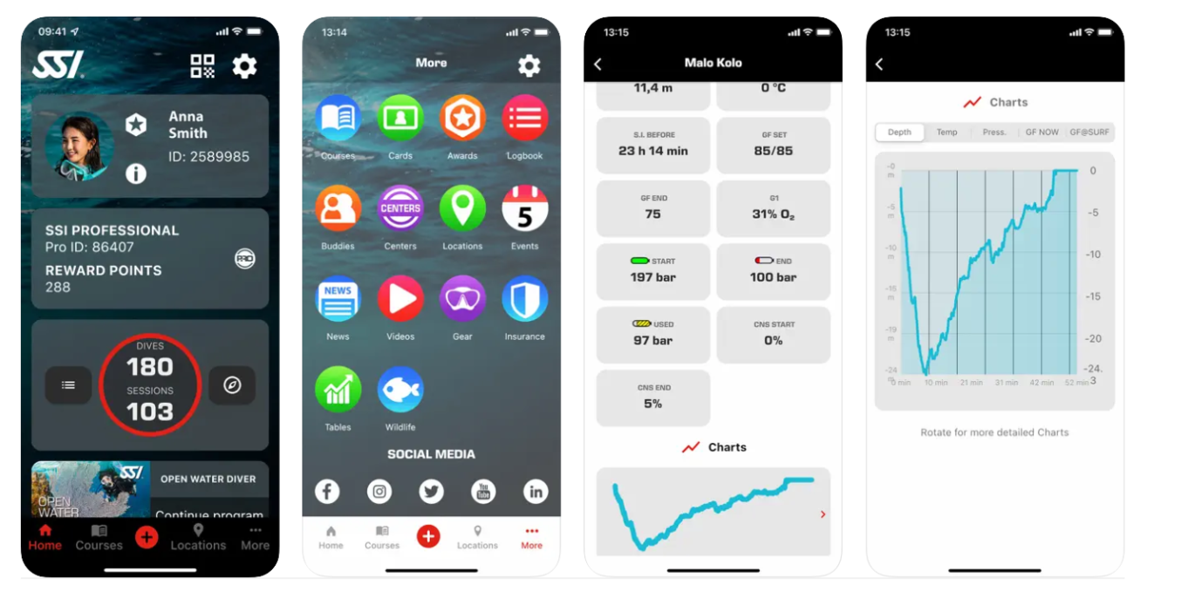

Figure 1 The MySSI application (SSI, 2022)

MySSI provides a personal diving diary that allows you to keep track of your dive site data, such as depths, temps, and other details. It keeps you safe and conscious of your air use. Furthermore, depending on your previous dives, it can send reminders and tips to make your next dive even more rewarding (SSI, 2022).

MySSI also allows you to review, search for, and save any diver-related material. The image and video-sharing features of the Android and iOS apps will allow you to chronicle and share your experiences with friends and family (SSI, 2022).

## **HCI Theory**

HCI is an acronym for Human-Computer Interaction. It is an interdisciplinary field of research that focuses on the design, assessment, and implementation of human-centered interactive computer systems. HCI's purpose is to develop technologies that allow humans to communicate with computers in meaningful and productive ways.

HCI is the study of how humans interact with computers and how technologies are designed to interact successfully with human users. This discipline includes topics such as user interface design, usability, accessibility, interaction design, user experience (UX) design, and the general human-centered design of computer systems (Rogers, Preece and Sharp, 2015).

### **Cognitive Psychology**

In the context of Human-Computer Interaction (HCI), "cognitive" refers to processes related to human cognition, which involves mental activities such as perception, attention, memory, language, problem-solving, and decision-making

Cognitive processes refer to the mental activities that encompass acquiring, processing, storing, and using information. These processes are crucial for how individuals perceive, understand, and interact with the world around them. Several key cognitive processes include (Rogers, Preece and Sharp, 2015):

* **Attention:** The ability to focus on specific aspects of the environment or certain stimuli while ignoring others. Attention is essential for processing information effectively and for managing the limited cognitive resources available.
* **Perception:** The process by which individuals interpret and make sense of sensory information from their environment. Perception involves the brain organizing and interpreting sensory input from various senses, such as sight, sound, touch, taste, and smell.
* **Memory:** The process of encoding, storing, and retrieving information over time. Memory involves various types, including sensory memory, short-term memory, and long-term memory. Cognitive psychologists study how information is retained and recalled.
* **Language Processing:** The comprehension and production of language involve various cognitive processes, including understanding the meaning of words, forming sentences, and engaging in complex linguistic tasks.
* **Problem-Solving:** The mental process of finding solutions to challenging or unfamiliar situations. Problem-solving often involves planning, decision-making, and critical thinking.
* **Decision-Making:** The cognitive process of choosing a course of action from among multiple alternatives. Decision-making is influenced by various factors, including personal experiences, emotions, and available information.
* **Learning**: The acquisition of knowledge and skills through experience, study, or teaching. Cognitive psychologists investigate how individuals learn and retain information, exploring factors that enhance or hinder the learning process.
* **Thinking:** Higher-order cognitive processes involve reasoning, abstraction, and conceptualization. This includes logical reasoning, creative thinking, and the ability to manipulate mental representations of objects or ideas.

In my design, I use techniques such as user testing, cognitive walkthroughs, and usability studies to gather feedback and refine my designs based on users' cognitive processes and behaviors. Continuous iteration and user feedback are crucial in creating interfaces that align with users' mental models and support efficient and satisfying interactions.

### **Interaction Design Theory**

A conceptual model refers to an abstract representation or mental model that people develop to understand how a system works. It comprises metaphors, concepts, relationships, and mappings between these elements, shaping users' comprehension of the system through their interactions(Johnson and Henderson, 2002).

In Human-Computer Interaction (HCI), a prototype is a preliminary version of a system or product that is used to test and evaluate design ideas before the full implementation (Johnson and Henderson, 2002).

In this report, I will present the following two types of prototypes:

* **Low-quality prototype:** This is the sort of prototype I use to illustrate the Diving app interface's skeleton. I developed this prototype with Axure design software.
* **Medium fidelity prototype:** I created this prototype to allow users to interact with the Diving app's UI. Furthermore, it allows users to conduct certain tasks inside the UI.

### **Modes of Interaction**

Interaction modes refer to the ways in which users can interact with a computer or a system. These modes encompass the methods and techniques through which users input commands or data into a computer and receive feedback(Rogers, Preece and Sharp, 2015).

* **Button interaction mode**: it refers to the use of buttons as a means for users to interact with a system or device.
* **Command Line Interface (CLI):** In a CLI, users interact with the system by typing commands into a text-based interface.
* **Voice-based Interaction:** Users interact by providing spoken commands, facilitated by voice recognition technology.
* **Touch-based Interaction:** Common in devices with touchscreens, users interact by tapping, swiping, and pinching.

**The interactive mode used for my prototype:** Although there are other ways to interact, I exclusively utilize touch and button mode in my prototype because it's quick and simple to use.

### **Types of Interaction**

Interaction types refer to the various ways in which humans and machines can engage or communicate with each other. These interactions can occur in a wide range of contexts, including human-computer interaction (HCI), human-robot interaction (HRI), and more.

Here, I'll discuss five interaction types: Instructing, Conversing, Manipulating, Exploring, and Responding.

* **Instructing:** Instructing involves users providing explicit commands or directions to a system. Users convey their intentions through specific instructions, and the system responds accordingly.
* **Conversing:** Conversing involves a more natural and dynamic exchange of information between the user and the system. This type of interaction often mimics human conversation, allowing users to communicate in a less structured manner.
* **Manipulating:** Manipulating interactions involve users directly controlling or manipulating objects or elements within a system. This can include gestures, touch, or other physical actions to influence the digital or physical environment.
* **Exploring:** Exploring interactions allow users to navigate and discover information or features within a system. Users are not necessarily giving explicit commands but are exploring the interface to find what they need.
* **Responding:** Responding interactions involve the system reacting to user inputs or actions. This can include acknowledging commands, providing feedback, or adapting to user behavior.

**The type of interaction that is used for my diving app prototype:**

In my Diving app, I have employed various types of interactions to optimize user experience and engagement. For the "Take Photos and Videos" feature, users are provided with detailed guidance through clear and easily understandable instructions. The "Monitoring Diving Activities" function is designed for exploration, enabling users to track a detailed insight into their underwater journey. Similarly, the interaction style for "Viewing Photos and Videos and Diving Logs" follows an exploratory approach, facilitating users in seamlessly navigating through their image and data collections. All these interaction styles aim to create a flexible and enjoyable experience, encouraging users to revisit and share their diving memories.

### **Design Principles**

According to (Rogers, Preece and Sharp, 2015) Design principles relate to the essential rules and concepts that direct the creation of interactive systems and user interfaces in order to improve the user experience as a whole.

There are some common design principles such as visibility, feedback, predictability, learnability, constraints, consistency, affordance, and discoverability. However, I will apply the following principles in my prototype.

* **Visibility:** This refers to the clarity of the system's status and the availability of relevant information to the user. A system should provide clear feedback about its current state and the available actions (Rogers, Preece and Sharp, 2015).
* **Feedback:** Users should receive timely and appropriate feedback for their actions. Feedback helps users understand the outcome of their actions and guides them in using the system effectively (Rogers, Preece and Sharp, 2015).
* **Constraints:** Constraints limit the possible actions a user can take. Well-designed constraints guide users toward intended actions and prevent them from making errors (Rogers, Preece and Sharp, 2015).
* Consistency: Consistency in design means that similar actions or elements should have consistent representations across the system. This helps users transfer their knowledge and skills from one part of the system to another (Rogers, Preece and Sharp, 2015).
* **Affordance:** Affordances are the perceived and actual properties of an object that suggest how it can be used. Design elements should have clear affordances to indicate their functionality (Rogers, Preece and Sharp, 2015).

### **Design Pattern**

A design pattern refers to a general, reusable solution to a common problem encountered in the design of interactive systems. Design patterns in HCI provide a way for designers to share best practices and proven solutions to recurring design challenges (Sharp, Rogers & Preece, 2019).

The design pattern that I used in my prototype:

* [**Perception and memory**](https://ui-patterns.com/patterns/perception-and-memory/list)

Perception involves the interpretation of sensory information from the environment. Memory is the process of encoding, storing, and retrieving information. Together, they form the foundation of cognitive processes, influencing how individuals understand and remember the world around them.

In perception and memory, I used the comprehension. Comprehension involves understanding and making sense of information. It is crucial for effective encoding into memory. Clear and well-designed information aids comprehension and facilitates memory retention.

The comprehension has various patterns, but I just utilize the two listed below in my prototype.

* [Recognition over Recall](https://ui-patterns.com/patterns/Recognition-over-recall): This pattern is used to reduce the amount of cognitive energy expended by users when entering data.
* [Conceptual metaphor](https://ui-patterns.com/patterns/Conceptual-metaphor): This pattern is used to explain abstract or entirely new topics and make it appear apparent what action to take.

# Design Process

## **Conceptual Design**

### **User Requirements**

The requirements employed in the design of the Diving application allow monitoring of diving activities such as depth, ascent time, air left in tank, dive duration, and sea temperature. This tool also allows users to review recorded dive history information. Another thing to keep in mind is that it allows the diver to take photographs and films during the dive, as well as review images and videos after the diver returns to land.

### **Problems and Solutions**

This application was created to address problems that divers may face such as providing information about the amount of gas left in the tank, helping divers manage their time underwater effectively, which can help divers. Diving avoids lack of oxygen and can affect the diver's life. Additionally, it assists divers to capture wonderful underwater moments through photos and videos. Last but not least, it helps store detailed information about each dive, including technical data and accompanying images and videos.

### **Hierarchical Model**

This is Hierarchical Model of the Diving App. This model presents two key function such as tracking and capturing.

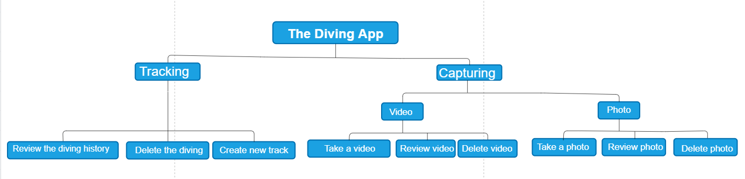

Figure 2 Hierarchical Model of the Diving App

### **Conceptual Model**

This is the conceptual model of the Diving App. It manifests metaphors that are used in this app. Besides, it also presents the types of interaction and modes of interaction that are used for this app. Another key thing to remember is that it describes how the user can interact with the app.

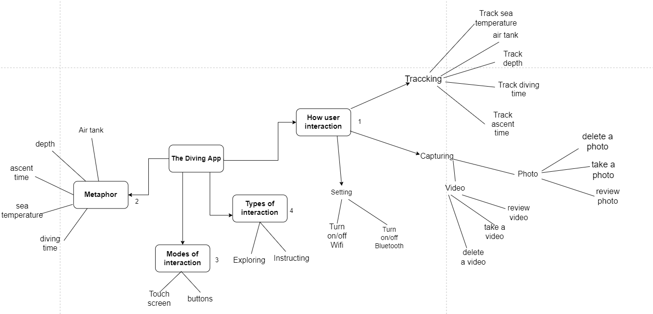

Figure 3 Conceptual Model

**Metaphors**

| **Icon** | **Description** |
| --- | --- |
|  | Temperature icon - show the status of the temperature |
|  | Depth icon- display the status of the diver’s depth |
|  | Ascent time – display the time it takes a diver to return to the water surface |
|  | Dive time – display the diving time of the diver |
|  | Air tank- display the status of oxygen remaining in the oxygen tank |
|  | Diving Icon- go to the Add New Diving page |
|  | Home Icon – go to the home page |
|  | Camera icon – go to the photo taking page |
|  | Tracking icon – go to the Add New Diving page |
|  | Setting icon – go to the setting page |
|  | Manage account icon - view the username and password |
|  | View terms and policies of this app |
|  | Log out icon – log out the account |
|  | Start icon – begin the diving |
|  | Pause icon - pause the process of diving |
|  | Stop icon – stop the the diving |
|  | Start icon – begin or continue the diving |
|  | Delete icon – remove an item |
|  | Wifi icon – display the wifi connection status |
|  | Bluetooth icon – display the bluetooth connection status |
|  | Battery icon - display remaining battery power |

## **Design principles**

I will describe how design principles will be included into my (interface) design and how the interactions in my prototype will demonstrate this.

* **Visibility**

Users can easily identify the state of the system in the prototype. Specifically, here users can monitor the status of parameters such as air tank and dive time and other indicators that are constantly updated.

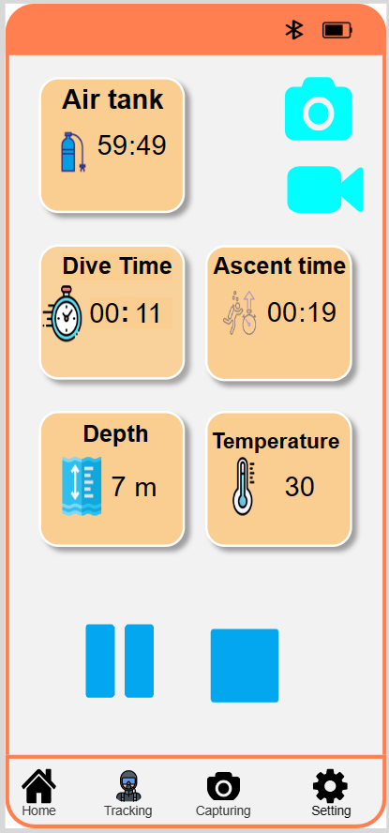

Figure 4 Visibility principle of my interaction design

* **Feedback**

Through my interaction design, users may receive feedback on the results of their activities.

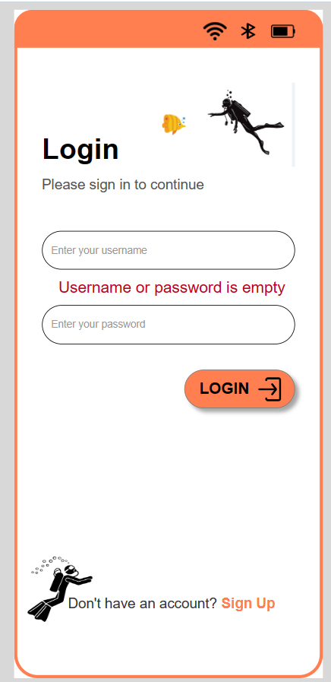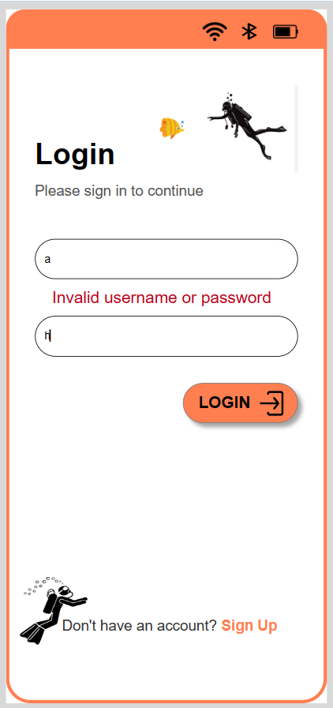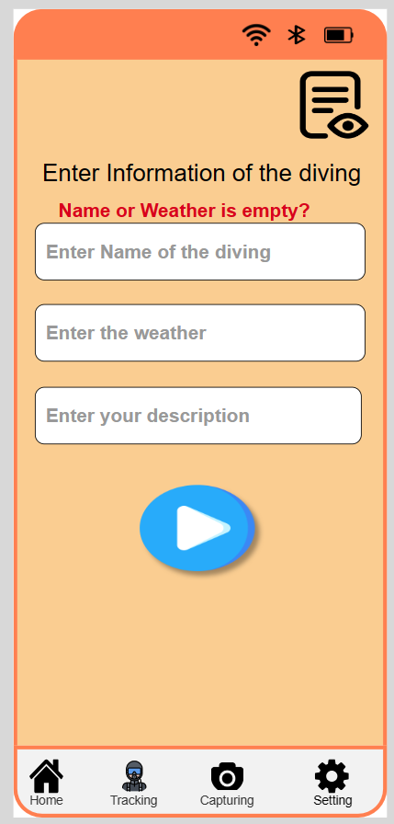

Figure 5 The feedback principle of my interaction design

* **Constraints**

My interface design restricts the actions that a user can do. Well-designed limitations direct users' behavior and keep them from making mistakes.

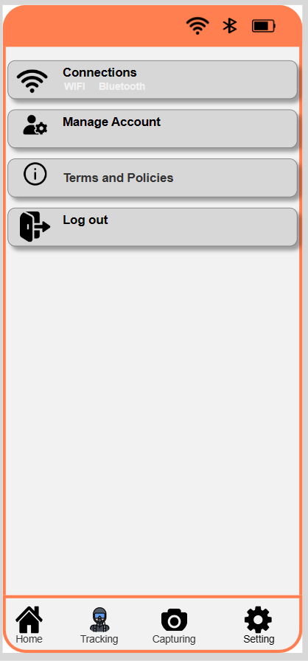

Figure 6 The Constraints principle of my interaction design

* **Consistency**

In prototyping, I always follow the rule of consistency. Specifically, I applied consistency in the colors of the interface and the colors of the icons and buttons to the prototype.

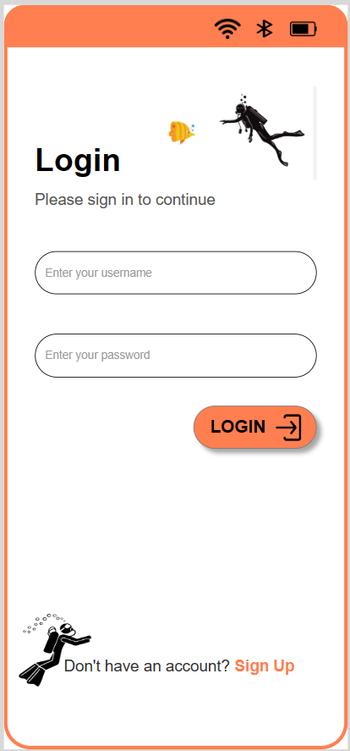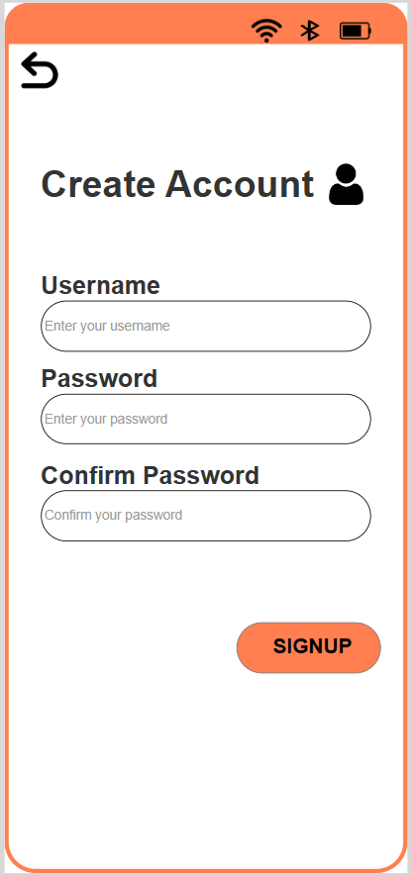

Figure 7 The consistency principle of my interaction design

* **Affordance**

Buttons in a my interface are designed to look clickable, often with a 3D appearance, shading, or an inviting color. This visual affordance signals to users that pressing the button will trigger an action.

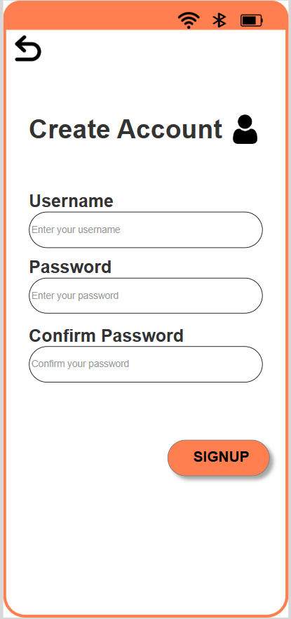

Figure 8 The affordance principle of my interaction design

# Prototype

## **Physical Prototype**

**Waterproof case:**

A waterproof case is a protective enclosure designed to prevent water from reaching and damaging the contents inside. These cases are commonly used to safeguard electronic devices, such as smartphones, cameras, and other gadgets, from water exposure (Armor, 2022).

The waterproof case was inspired by the image below, so my product will be quite similar to this waterproof case.

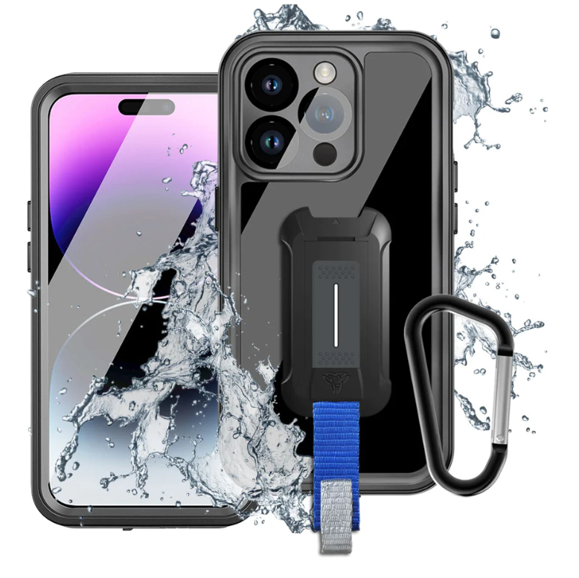

Figure 9 Waterproof case (Armor, 2022)

The image below illustrates the front and back of my waterproof case.

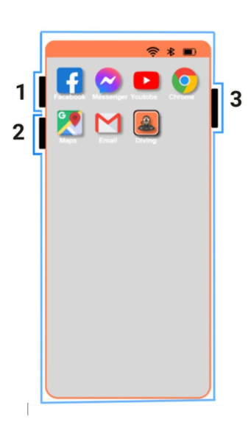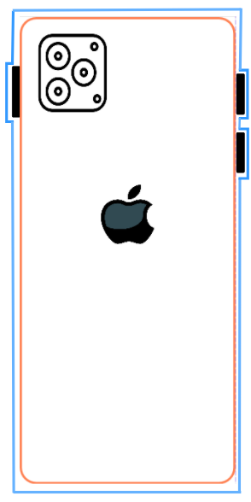

Figure 10 The front and back of my waterproof case

The following describes how to use these buttons:

* Users can interact with these buttons by pressing them.
* Button 1 - used to increase volume
* Button 2 - used to decrease volume
* Button 3 - used to turn the phone on and off

## **Low-fidelity Prototype**

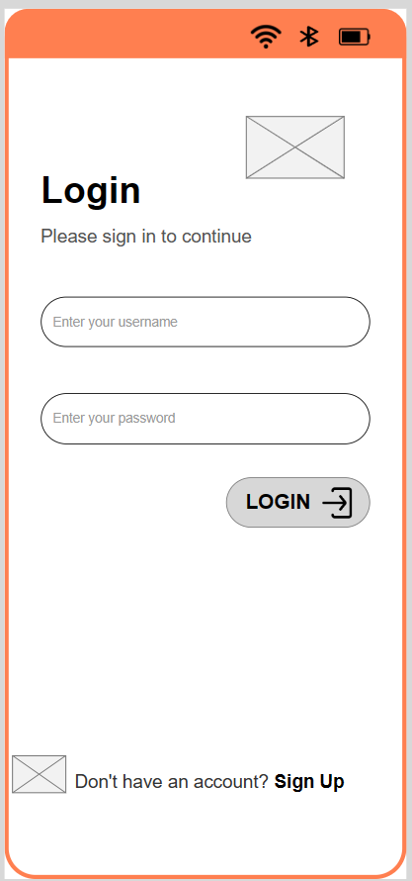

Figure 11 The Diving application’s the login page in low-fidelity

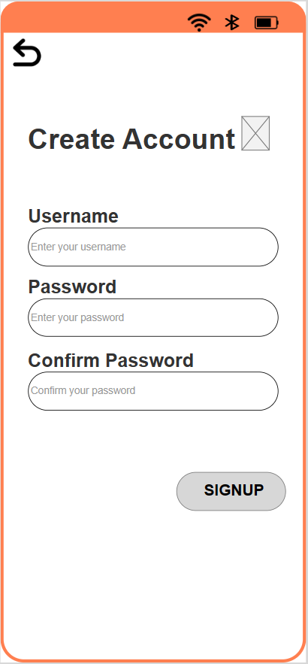

Figure 12 The Diving application’s the sign up page in low-fidelity

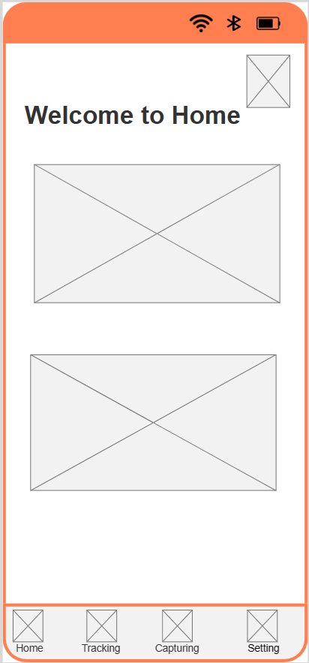

Figure 13 The Diving application’s the home page in low-fidelity

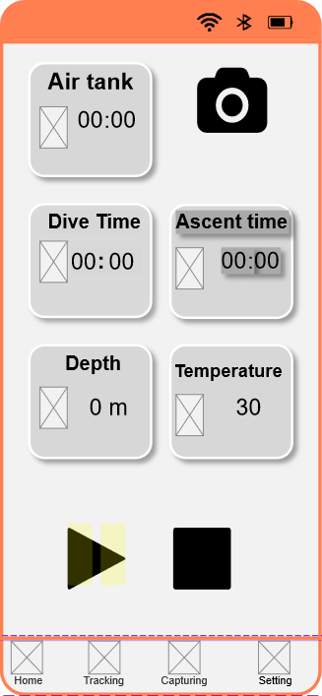

Figure 14 The Diving application’s the tracking page

## **Mid-fidelity Prototype**

This is an application icon.

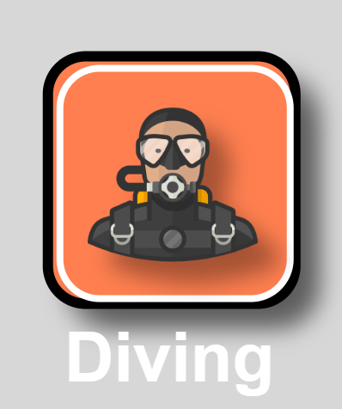

Figure 15 The application icon

This is the Diving application's login. This is the UI that appears firstly when the user opens the Diving app.

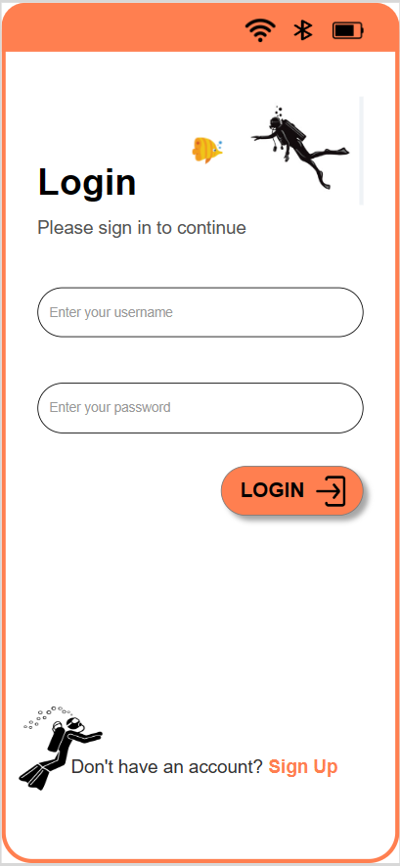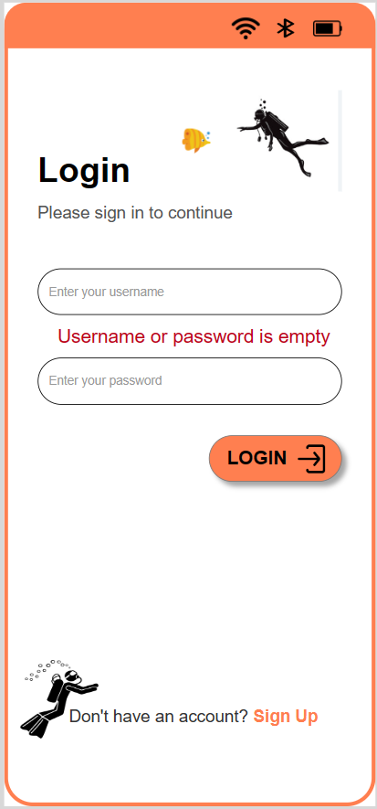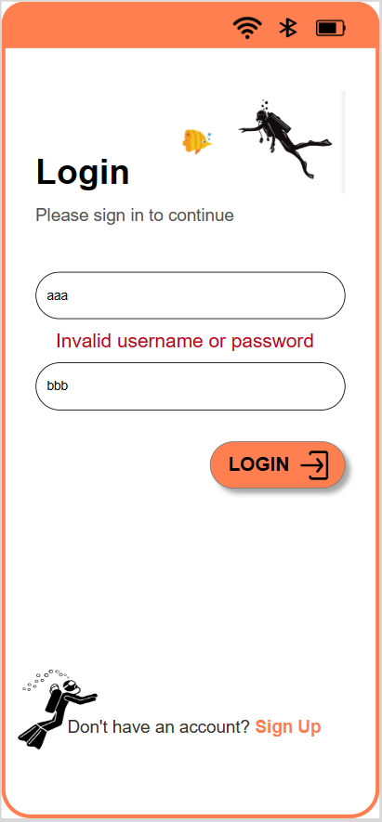

Figure 16 The Diving application’s the login page in Mid-fidelity

The notification "Username or password is empty" will appear if the user doesn't provide any information. Additionally, a notice will appear if the user enters the incorrect username or password.

This is sign up interface of diving application.

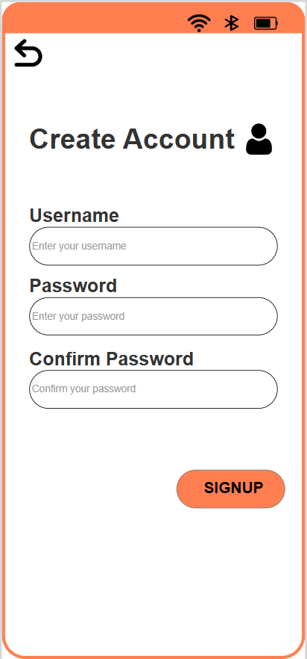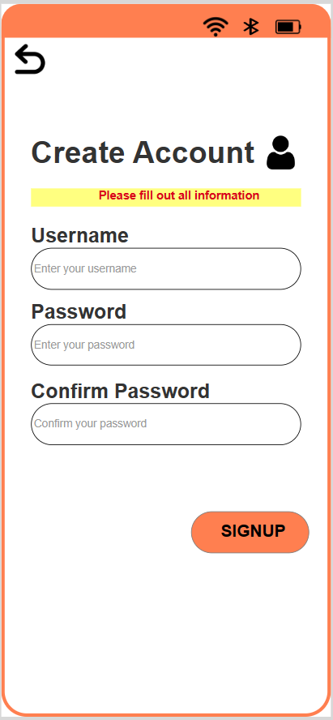 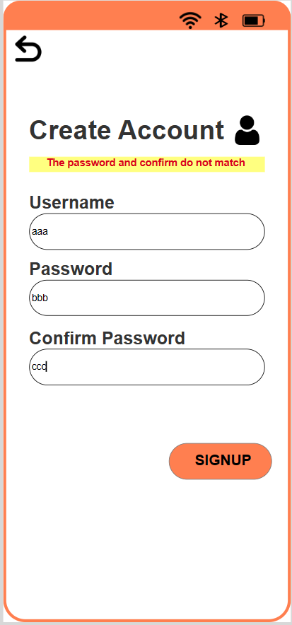

Figure 17 The sign up interface of diving application in mid-fidelity

Above is the application's registration page. A message will be displayed If the user does not enter any information and clicks on the register button. Additionally, if the user enters the password and confirms the password do not match, a message will be displayed.

When logged in successfully, the interface will be displayed as the image below

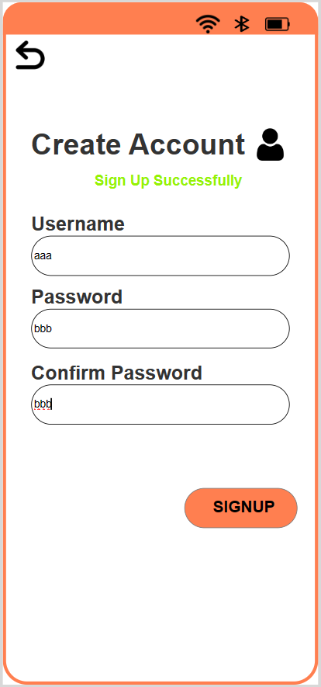

Figure 18 Log in successfully in mid-fidelity

This is home page of the Diving app. At the top of this page, I've created an icon to navigate to a dive tracking page. Additionally, below is a navigation bar that includes Home,Trackin, Capturing and Setting options used to navigate through different pages.

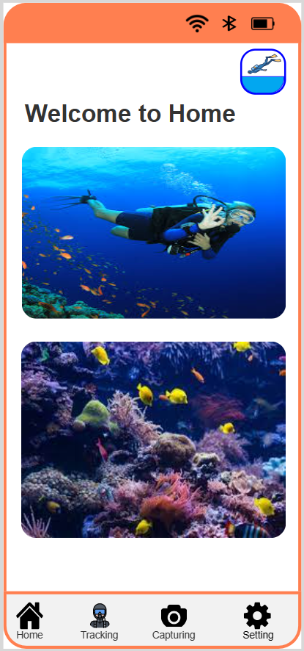

Figure 19 The Diving application’s home page in mid-fidelity

This is the interface used to add a new dive activity. This interface will be displayed when the user clicks on the Tracking option of the navigation bar below the screen.

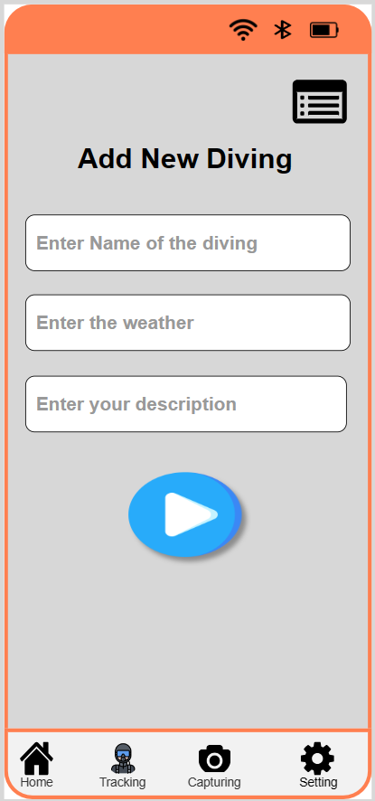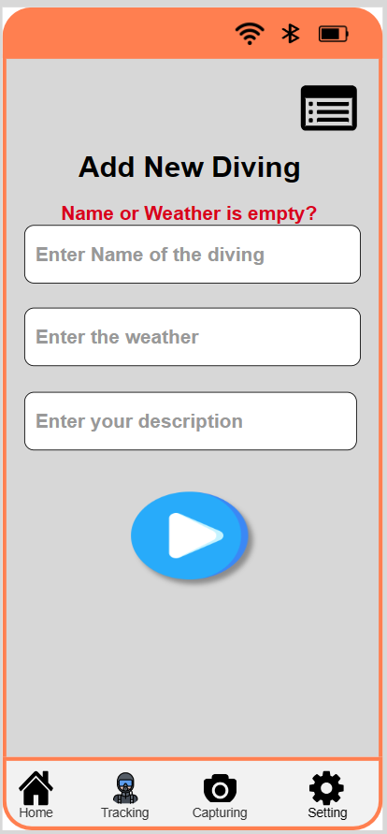

Figure 20 The Diving application’s Add New Diving page in mid-fidelity

If the user does not enter any information and clicks start, a message will be shown like the image above.

When the user has entered all the information at the Add New Diving and clicked start, the interface below will be displayed. On this page, users can press a  button to temporarily stop and view the indicators. Another thing to remember, the user can press a  button to completely stop the diving activity. After stopping diving activity, users can review the diving history as the presented below.

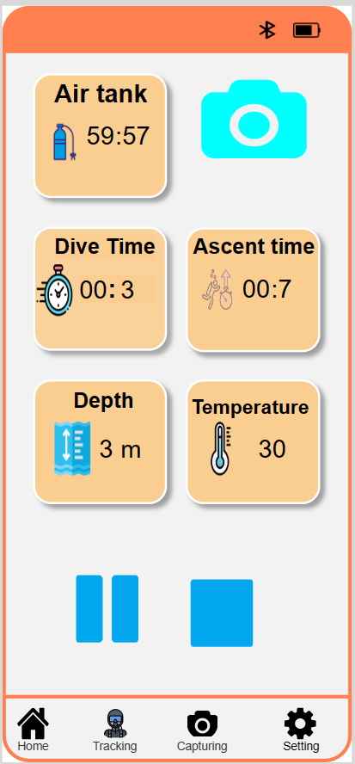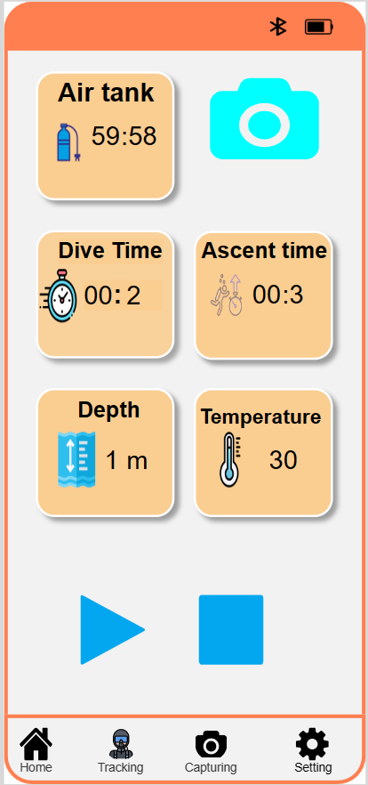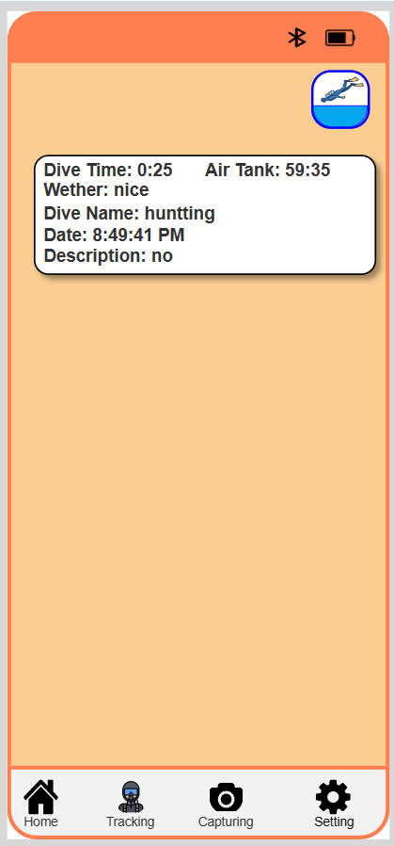

Figure 21 The Diving application’s Tracking page in mid-fidelity

This is the photography interface that will appear when the user clicks on the Capturing option of the navigation bar below the screen. On this page users can take photos. In addition, after taking a photo, users can click on the  icon to view a list of images that is taken. Another key thing to remember, users can view larger images by clicking on the image displayed on the list. Last but not least, users can switch to the page used to record the video by clicking on the  icon.

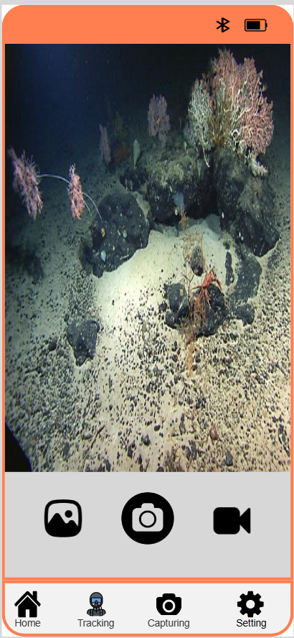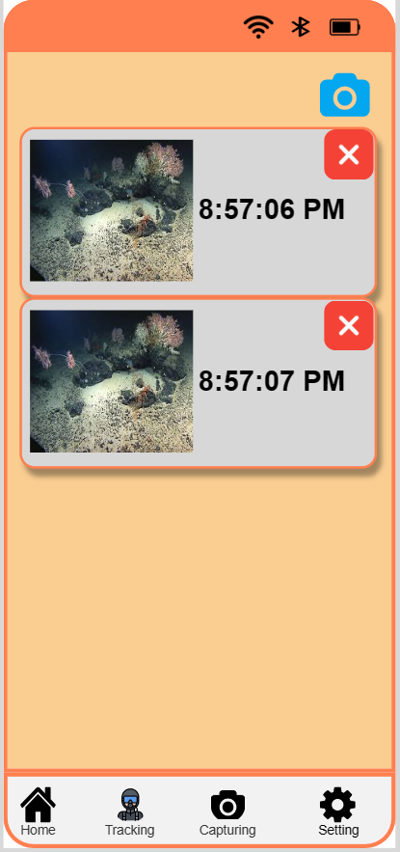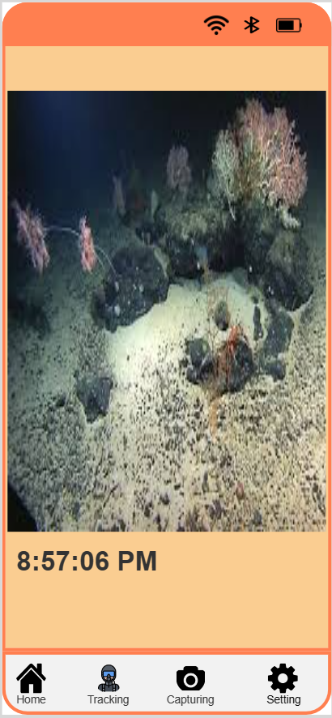

Figure 22 The photography interface of the Diving applicarion in mid-fidelity

This is the video recording interface, on this page users can record a video by clicking on the icon , While this video is being recorded, an icon will be hidden and displayed continuously until the user clicks on the  icon again to stop. Additionally, after taking a video, users can click on the  icon to view a list of videos that is taken. Finally, the user can also return to the page used to take a previous photo by pressing on the  icon.

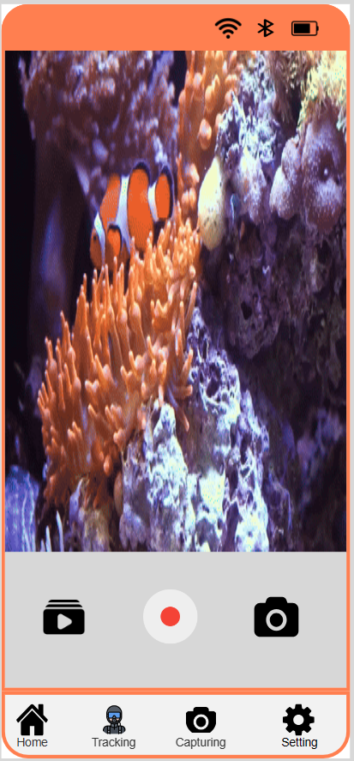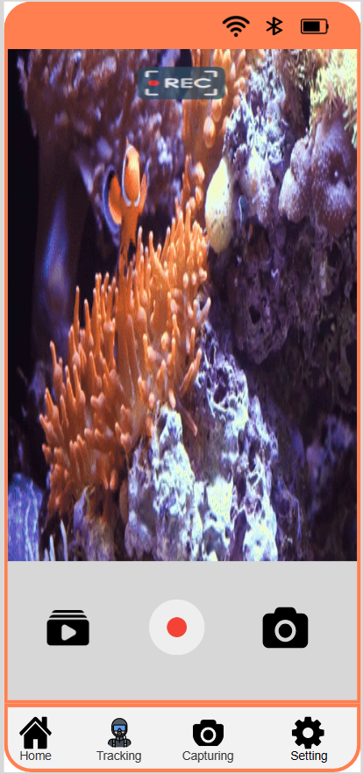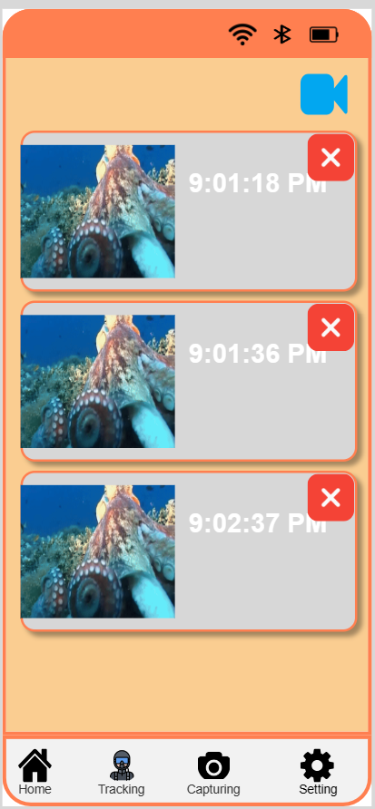

Figure 23 The video recording interface of this application in mid-fidelity

This is the settings page used to turn wi-fi and bluetooth on and off when users click on the Connections option.

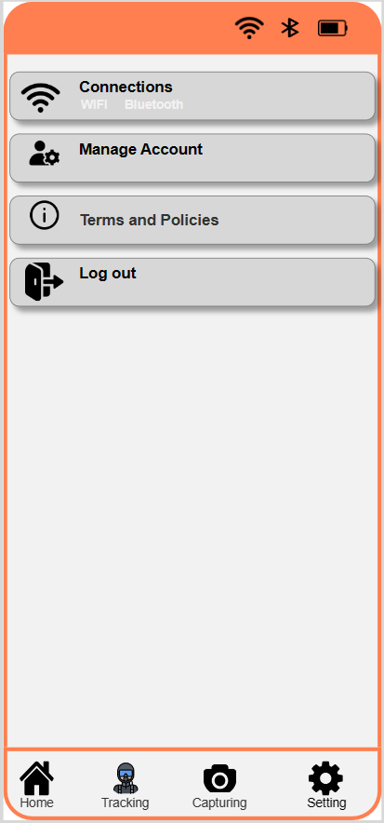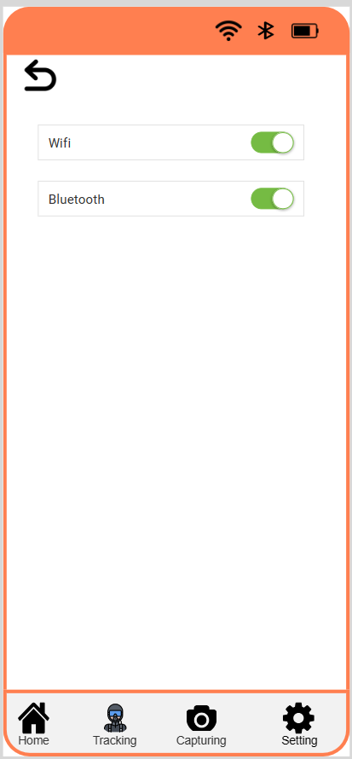

Figure 24 The connections setting page of this application in mid-fidelity

This is the page used to view the user's name and password by clicking on the Manage Account option.

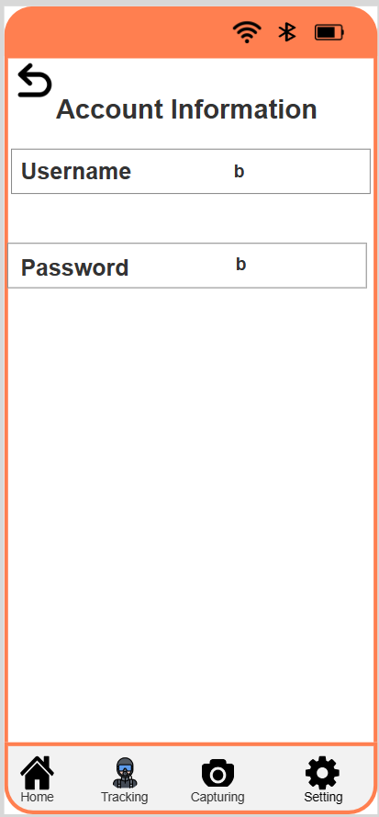

Figure 25 The account management page of the Diving application in mid-fidelity

This is the Page used to talk about terms and policies. The user can view them by clicking on the Terms and Policies option.

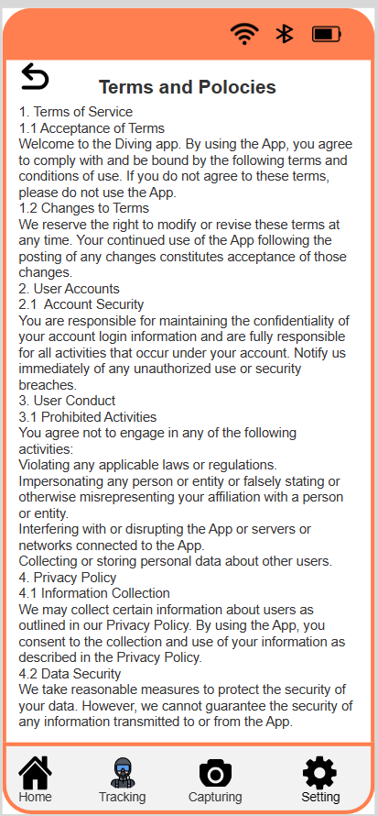

Figure 26 The terms and policies page of the Diving app in mid-fidelity

This is the Page used to log out the account, The user can log out the account by clicking on the lock out option and selecting Yes.

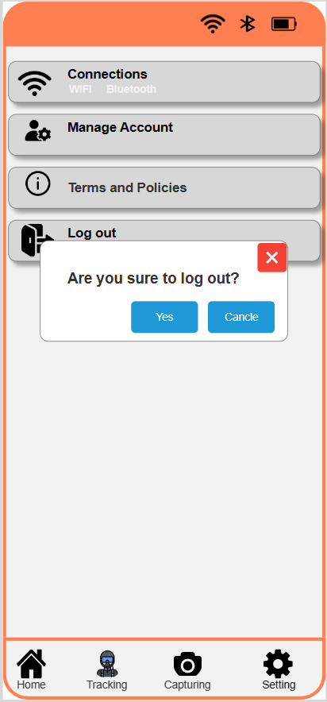

Figure 27 The log out function of the Diving app in mid-fidelity

# Research Study

**Hypotheses:**

There are two hypotheses that I propose:

1. Divers with enough ability can learn from my application with an easy-to-use, memorable, and friendly interface.
2. The second hypothesis is that the application I created met the user's requirements and expectations.

In this research, I choose quantitative and qualitative methods. In this methods, I use surveys to collect data. The participants in this survey were divers ranging in age from 18 to 45 years old. I sought out participants for this survey from diving schools.

Participants' survey responses will be gathered for this study using Google Forms, enabling further research and application development.

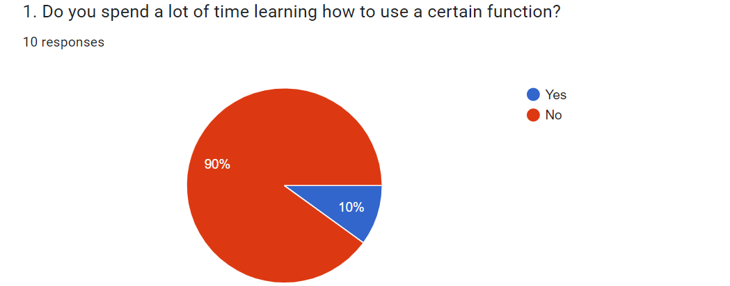

Figure 28 The research question 1 of the Diving app

A glance at the survey results of question 1 shows that 90 percent of divers surveyed chose No. Meanwhile, ten individuals voted Yes. This means that my application functions are easy to use because it is easy to understand.

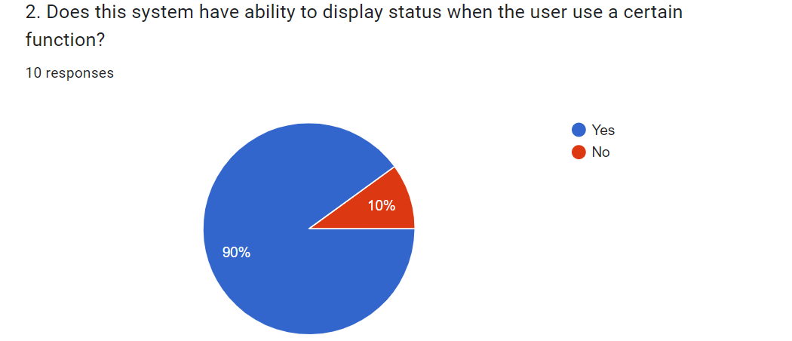

Figure 29 The research question 2 of the Diving app

A glance at the survey results of question 2 shows that 90 percent of divers surveyed chose Yes. Meanwhile, ten individuals say No. As a result, progress updates help users know the status of the work being done. This helps them better understand time remaining, progress and can reduce anxiety.

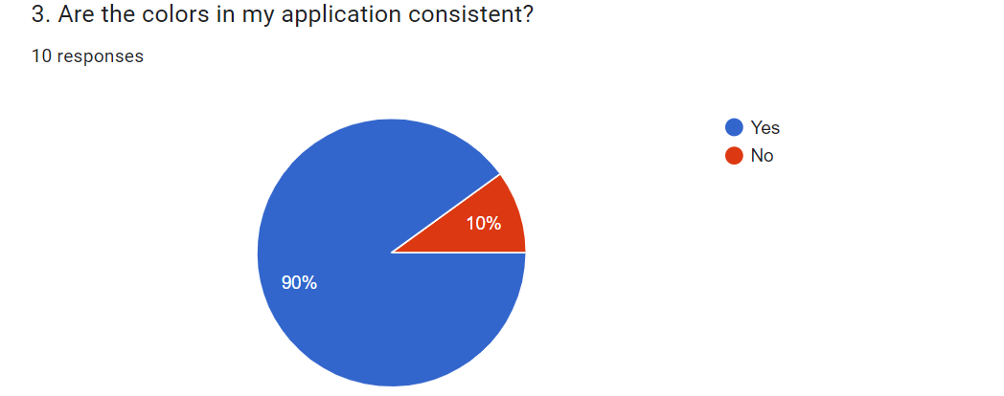

Figure 30 The research question 3 of the Diving app

A glance at the survey results of question 3 presents that 90 percent of divers surveyed chose Yes. Meanwhile, ten individuals say No. Thus, The color of the Diving app was chosen by me following the design principle, so it is very uniform in color

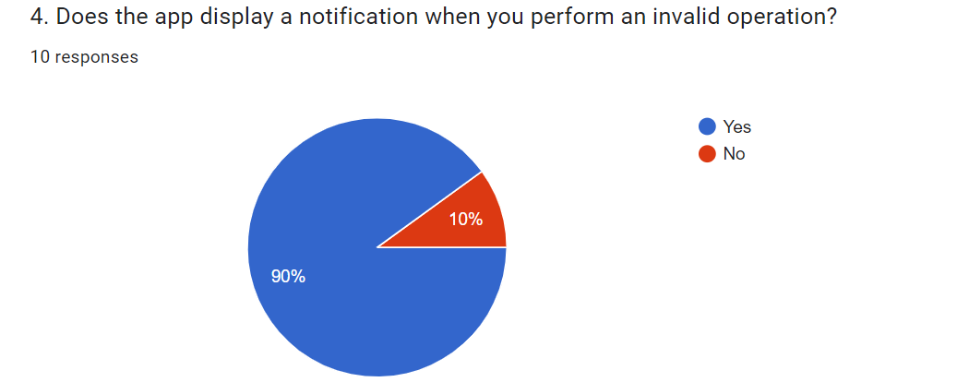

Figure 31 The research question 4 of the Diving app

A glance at the survey results of question 4 presents that 90 percent of divers surveyed chose Yes. Meanwhile, ten individuals voted No. This means that my application complies with the visibility principle, it helps users know whether their actions are right or wrong.

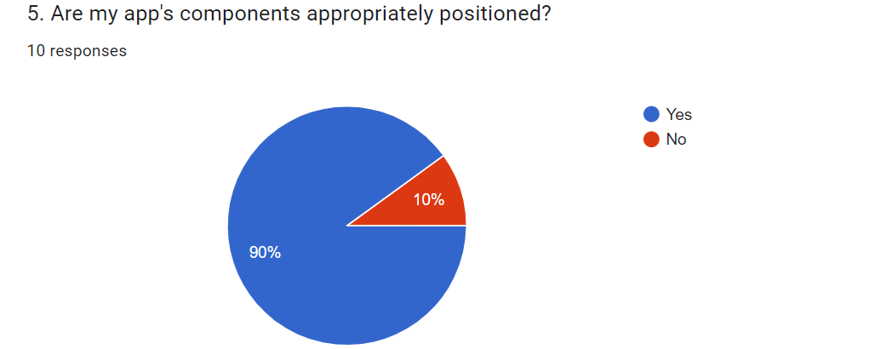

Figure 32 The research question 5 of the Diving app

A glance at the survey results of question 5 presents that 90 percent of divers surveyed chose Yes. Meanwhile, ten individuals voted No. This means that the components in my application are arranged sequentially, which makes it easy for users to perform functions.

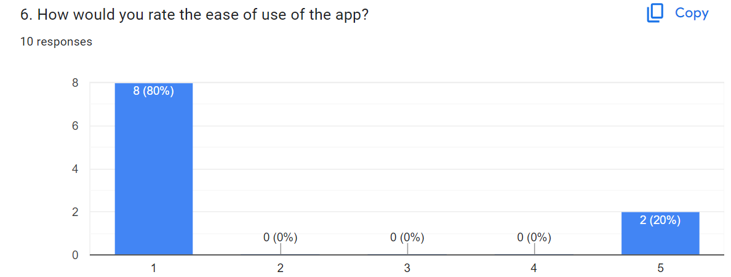

Figure 33 The research question 6 of the Diving app

Note: Ratings range from 1 to 5, in which 1 is very easy and 5 is very difficilt

A glance at the survey results of question 6 presents that 80 percent of divers surveyed chose Yes. Meanwhile, ten individuals voted No. This means that my application is really easy to use.

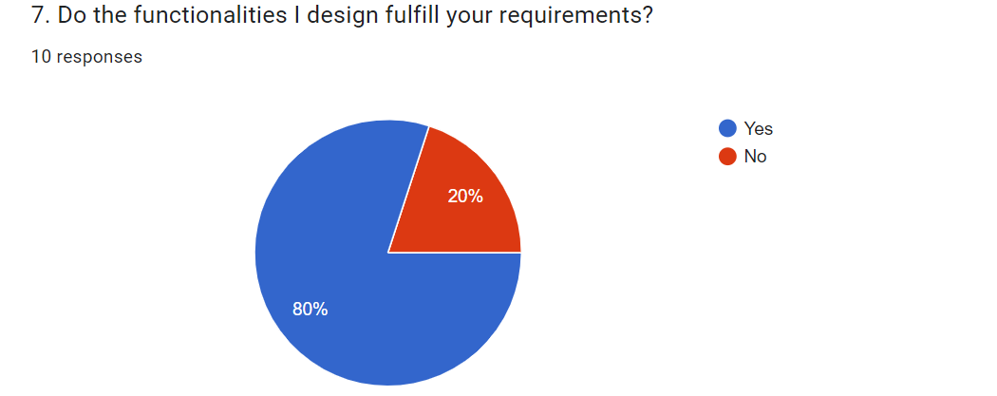

Figure 34 The research question 7 of the Diving app

A glance at the survey results of question 7 presents that 80 percent of divers surveyed chose Yes. Meanwhile, ten individuals voted No. This means that my prototype almost met user requirements.

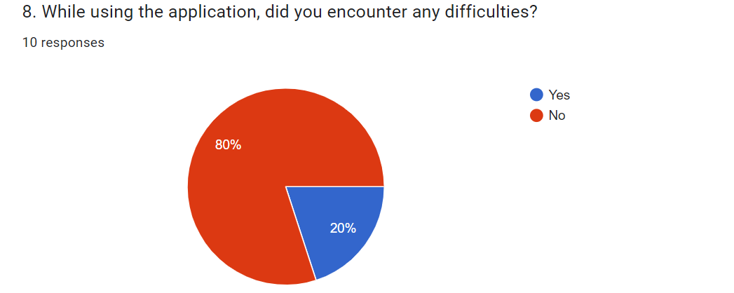

Figure 35 The research question 8 of the Diving app

A glance at the survey results of question 8 presents that 80 percent of divers surveyed chose Yes. Meanwhile, ten individuals voted No. This means that my application is quite easy to use.

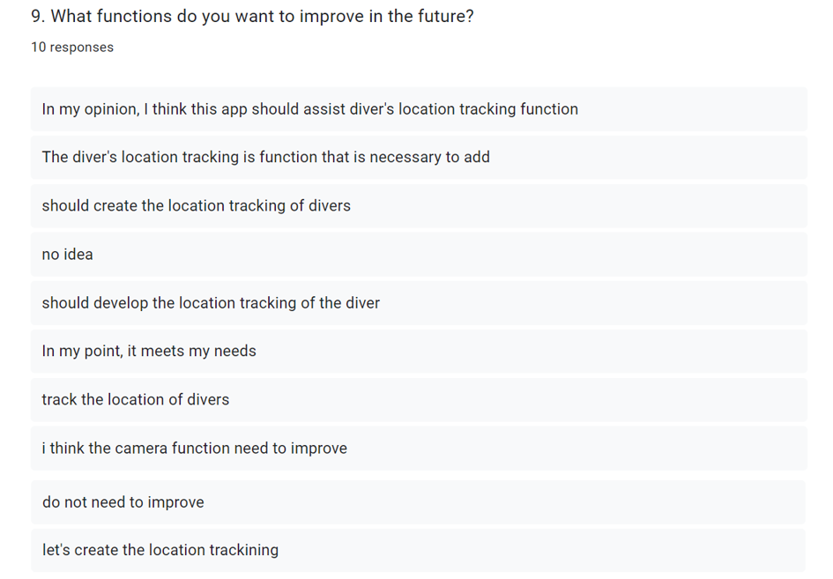

Figure 36 The research question 9 of the Diving app

A glance at the survey results of question 9 manifests most people think that the application should develop a function to track the location of divers.

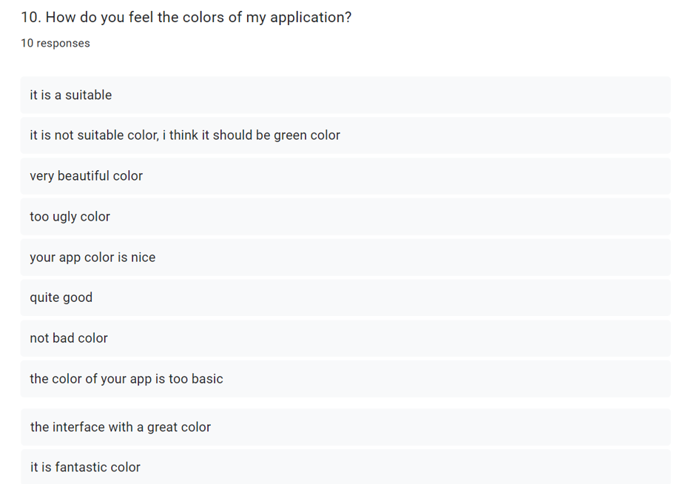

Figure 37 The research question 10 of the Diving app

A glance at the survey results of question 10 shows that most people think that the application’ color is pretty beautiful and suitable. This means that the interface of the Diving app is really great.

In conclusion, the survey results of questions 1, 2, 3, 4, 5, 6, 8, and 10 demonstrate that hypothesis 1 is right since I used design principles in my prototype, resulting in a friendlier interface that is easy to learn and use. Furthermore, my prototype also meets most of the functions that users need; this is proven through the result of question 7.

* **The Heuristic of Nielsen (10 heuristic methods):**
* **Visibility of system status**

My design should always bring users up to date on what is going on. Users may specifically check the status of parameters such as air tank and dive time, as well as other indications that are regularly updated, on this page.

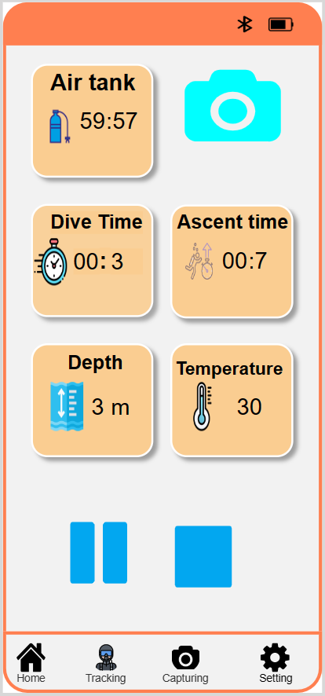

Figure 38 Visibility of system status

* **Match between the system and the real world**

To make my designs understandable, I always apply the language of the users. I specifically utilize terms, ideas, and concepts that the user is familiar with rather than internal jargon.

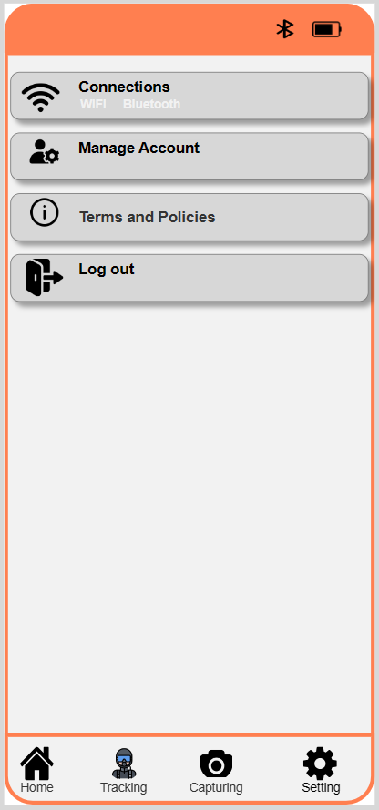

Figure 39 Match between the system and the real world

* **User control and freedom**

My design includes obvious "Delete" buttons as well as confirmation prompts to avoid unintentional deletions from having major implications, giving users control over their actions.

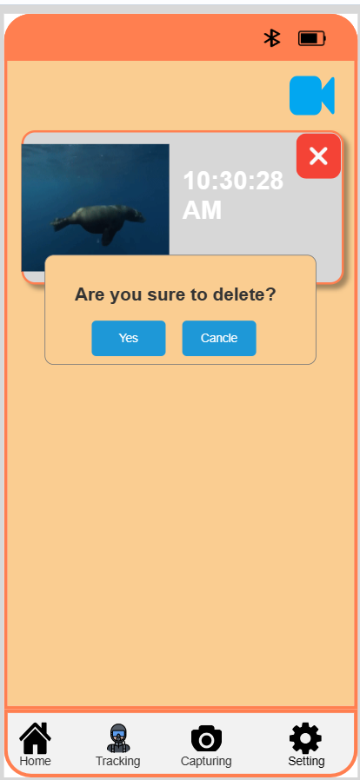

Figure 40 User control and freedom

* **Consistency and standards**

My designs follow the principles of consistency and standards. Specifically, I have consistently used familiar symbols to help users quickly understand the information displayed.



Figure 41 Consistency and standards

* **Help users recognize, diagnose and recover from errors**

If the user does not enter any information in the login form and clicks the login button, my design will provide a clear and specific error message. In addition, If the user enters the password and the password confirmation does not match, a clear message will be displayed.

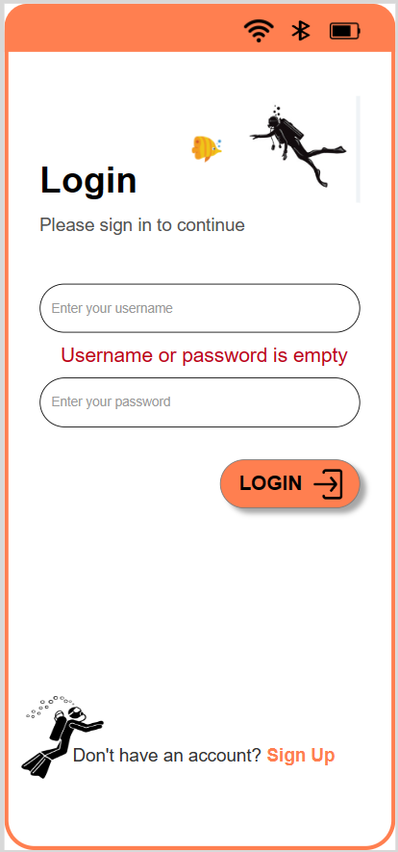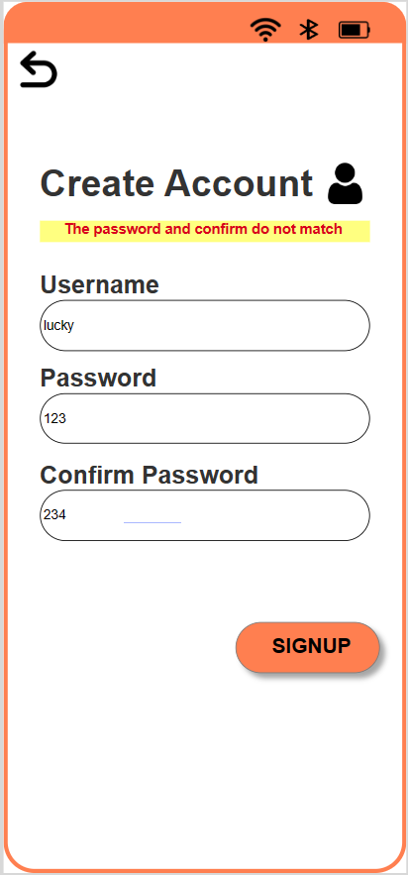

Figure 42 Help users recognize, diagnose and recover from errors

* **Error prevention**

When a user inputs incorrect information, my prototype shows a notification to help the user avoid making the same mistake in the future.

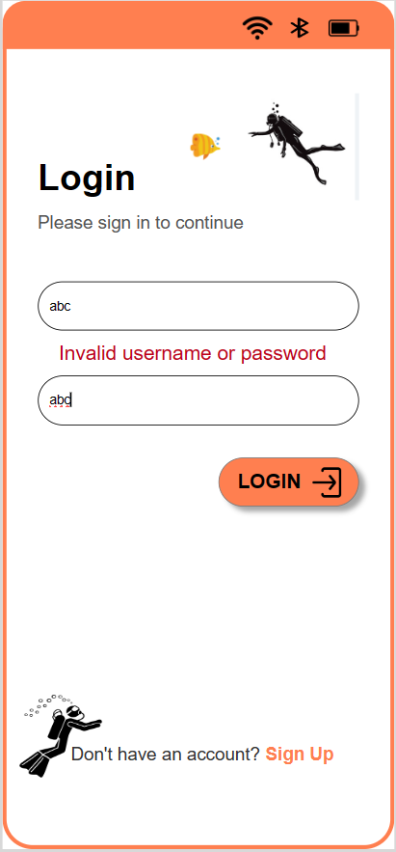

Figure 43 Error prevention

* **Recognition rather than recall**

My designs use visual icons or symbols to represent different types of events. This means that, it helps users not need to remember the details of each event.



Figure 44 Recognition rather than recall

* **Flexibility and efficiency of use**

My design allows users to switch between interfaces rapidly by using shortcuts, permitting them to execute a quick action and save time. For example, while examining information connected to diving activities, users can press the camera symbol to capture a photo.



Figure 45 Flexibility and efficiency of use

* **Aesthetic and minimalist design**

My design removes unnecessary elements and features to create a clean and uncluttered look. The icons in this interface are extremely simple, however, it help users visualize the operations they can use. For example, to take a photo they need to click on the icon in the middle, and to record a video they need to click on the record icon.

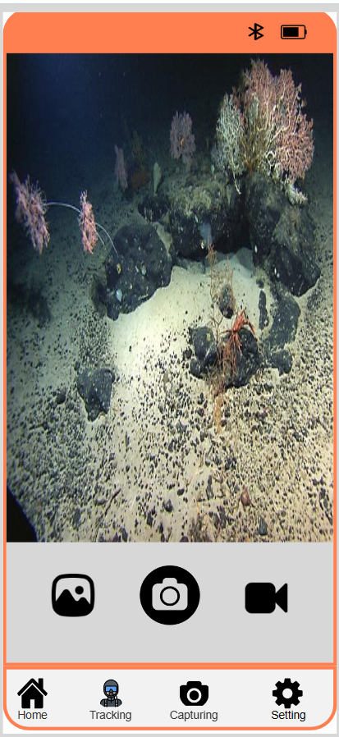

Figure 46 Aesthetic and minimalist design

* **Help and documentation**

My Design provides documentation to help users understand the policies and terms when users use it.

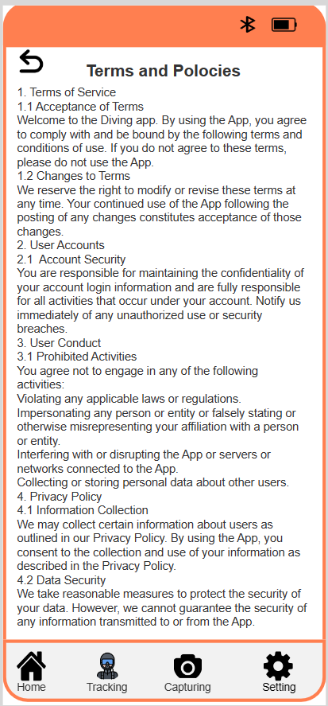

Figure 47 Help and documentation

# Conclusion

* **Evaluation of my achievements**

Through this report, I gained an excellent overview and grasp of HCI concepts such as modes of interaction, kinds of interaction, design principles, and conceptual models. Furthermore, I include these notions into my prototype, which aids in increasing user happiness and utilization. Furthermore, using HCL allows my prototype's user interface to be developed to be interactive and user-friendly. Finally, HCI aids in the development of a thorough knowledge of user wants, preferences, and even behavior, resulting in a prototype that accurately mirrors real-world requirements.

Another important point to remember is that I created a prototype with all of the required features. Most importantly, my design allows divers to take underwater images and videos. Furthermore, it allows users to monitor diving activities such as the quantity of air remaining in the tank, dive duration, ascent time, and so on. Finally, when the diver comes to land, he or she can check images, videos, dive logs, and activity information.

* **The following are some drawbacks I've faced:**

When I was creating this prototype, I got into a few issues. To begin, it was advised that I use Axure RP to make this prototype, but this is the first time I've learned of it, so I'll need a lot of time to learn how to use it. Second, in order to create an effective prototype, I need to spend time learning about general design principles, which takes a lot of time and work. Finally, I had trouble finding and studying relevant diving applications.

* **The potential next steps for this project**

Although my project met the majority of the divers' requirements, my survey revealed that users are looking forward to the development of increased diver location tracking, so in the future I will further develop this feature to provide the best experiences to divers, as well as commercialize it to earn more income from it.

# References

Armor, 2022. [Online]   
Available at: https://armor-x.com/products/mx-iph-14pmx-iphone-14-pro-max-waterproof-case-ip68-shock-water-proof-cover-w-x-mount-carabiner  
[Accessed 2023].

Johnson and Henderson, 2002. [Online]   
Available at: https://interactions.acm.org/archive/view/january-2002/conceptual-models1

Rogers, Preece and Sharp, 2015. *Interaction Design: Beyond Human-computer Interaction.* s.l.:Wiley.

Sharp, Rogers & Preece, 2019. *Interaction Design: Beyond Human-Computer Interaction.* s.l.:Wiley.

SSI, 2022. [Online]   
Available at: https://www.divessi.com/en/join-ssi/register-free/myssi-app  
[Accessed 2023].

# Appendices

Link of the survey questions: <https://forms.gle/iwSUf99y1sALG5VNA>

I've screenshotted all of the survey questions below.

